An Enhanced Approach for Disease Identification in Betel Leaf Using Convolution Neural Networks
Dr. S. Kirubakaran¹, B. Bhanu Teja², Mohith Bacha³
¹Professor,Department of CSE (AI&ML),CMR College of Engineering & Technology, Hyderabad, Telangana, India
^{2,3} Student, Department of CSE (AI&ML),CMR college of Engineering & Technology, Hyderabad, Telangana, India
dr.s.kirubakaran@gmail.com

ABSTRACT

Betel leaf is a valuable crop in most tropical areas as it not only has medicinal value, cultural value and can help in boosting the economy of farmers. Fungal and bacterial infections like leaf rot, leaf spot, anthracnose and bacterial leaf infections usually lower the yield and quality of the betel leaf, however. These diseases need to be identified early enough to reduce losses and enable them to be treated in time. This paper gives a case study of an automated disease-detection system on betel leaves, which is based on deep learning. The way is to preprocess leaf images, amplify texture features with the help of Gabor filters, and, finally, classify the diseases with the help of a convolutional neural network relying on the ResNet50 architecture. To measure the effectiveness of the model, we train and test the model on conventional performance measures. The experiments prove that the offered system correctly identifies healthy leaves and the leaf infected with some diseases. The framework will assist farmers and other agricultural worker make a wise decision in the production of betel leaf, and early diagnosis of diseases.
Keywords: Betel Leaf, Plant Disease Detection, Gabor Filter, ResNet50, Deep Learning, Leaf Disease Classification, Smart Agriculture

- INTRODUCTION
The betel leaf farming is of significance to numerous farmers particularly in the tropical regions where the crop is valued due to its medicinal value, cultural value, and the monetary value [6]. It is then important to maintain the betel leaf plants in a healthy condition. However, these crops are very prone to fungal, bacterial and viral infections [6,15]. The disease is not noticed in time, then it may quickly move to other fields, reducing the quality and quantity of the harvest, and leading to severe losses of finances [6].
Early detection of diseases is essential to reduce the crop damages and to have healthy crops [7,16]. Disease is indicated by visible changes in the texture, color and structure of leaves [7]. Farmers or agricultural experts are traditionally inspecting plants manually and identifying any issues [4]. This is only practical on a limited scale since it involves a lot of human judgment and is ineffective when large scale is involved [4,17]. There is low access by experts, inconsistent checks and late detection of defects which makes the effectiveness of manual inspections even less [17].
In the modern world, most of the farms continue to use visual inspection of leaves [4]. Color, texture, or shape changes are used to identify the health of the plant being sought by the farmers [6]. Although it is a pragmatic approach, it is too much based on the experience [4]. Big farms or places where the experts can not access it so easily make the process slow and less dependable [17]. Minor symptoms are mostly overlooked and before the disease becomes evident the extent of the damage can well be on the ground [7].
New tools can be provided to farmers with the help of artificial intelligence advances [7,18]. Deep-learning-based image-based disease detection systems have the ability to process photographic information of leaves and identify patterns of disease, which a human might overlook [7,18]. Convolutional Neural Networks (CNNs) are particularly good at this task, where they can learn fine details like the texture variation and also color variation associated with the disease in the plants [7,18]. Such systems are an alternative to manual inspection where the process is quicker and consistent [16].
Problems with the detection systems of betel leaf disease still exist in spite of these developments [3,5]. Most of the models do not focus on generalization, clarity of the features, or application in real farming environments, only they focus on classification accuracy [5,16].
Most of the solutions that are in place give more emphasis to technical accuracy rather than the real world [5]. Farmers require systems that are accurate and at the same time simple, reliable and able to support them in time [6,17]. To address this requirement, this proposed work proposes a betel leaf disease identification system that is based on image preprocessing and deep learning classification [1,2]. It is aimed at assisting farmers in identifying diseases at early stages, minimizing losses in crops, and producing more sustainable and healthier crops through available technology [6,7].
The deep learning methods used in plant disease detection have been used to detect other common crops such as tomatoes, apples and olive leaves. Conventional neural networks in such cases were found to generalise effectively when the environmental conditions were varied [10,11,12,13]. The integration of deep learning and feature-reduction techniques, referred to as hybrid architectures has enabled the faster and more accurate classification process, as well as reduced the cost of computation [14]. Comparative studies of classical image -processing and more recent machine-learning models have found that deep learning is more accurate and can scale better in all cases [19].
- RELATED WORK
Rashidul Hasan Hridoy and others developed a set of betel leaf images to improve the detection of the disease by AI. To support effective machine-learning models in early and consistent diagnosis, they divided the field images into healthy and disease-affected and augmented them to enhance diversity [1].
The optimized deep-learning system mentioned by A. S. Devi and colleagues was used to identify diseases in betel leaves. The pictures were pre-processed, i.e. resized and denoised. Then dimensionality reduction was done by principal component analysis followed by classification using VGGNet and MobileNet CNNs. The outcome is correct, early diagnosis that may assist farmers reduce losses on economic grounds [2].
Femi David et al. came up with a machine-learning algorithm to detect betel leaf diseases. They divided the images into region-of-interest with the help of region-of-interest techniques, got the texture features with the help of the Gray-Level Co-Occurrence Matrix (GLCM), and classified the texture features with the help of the Extreme Learning Machine. The procedure was accurate and can be used to monitor large areas of fields in a short time [3].
Indrajeet Kumar et al. suggested an image-processing technique to determine the age of betel leaf and illnesses in leaves. They initially turned the images to grey scale and eliminated noise. Then, they did segmentation based on Otsu thresholding. Lastly, they also used K-means clustering to identify infected regions and this is a low-cost method of fast and efficient measurement compared to manual inspection [4].
A machine -learning approach to betel leaf disease detection was proposed by Rajkumar G. et al. Its strategy is based on the median filtering, K-means segmentation, and Gray-Level Co-occurrence Matrix features, which are inputted to an SVM classifier. This combination allows to enhance accuracy and allows to monitor on large scale [5].
Atreyee Banerjee et al. examined significant fungal infections of betel-vine at Indian farms. They included foot rot, collar rot, leaf spot and powdery mildew and how it affects yield and how it is critical to identify early using AI-aided techniques [6].
S. Mishra et al. introduced a deep learning based model of transfer learning to detect plant leaf disease, which can be more accurate with small data sets and can be diagnosed faster and efficiently in the automated agriculture monitoring applications [7].
H. Chen et al. developed a convolutional neural network with attention to determine the presence of plant diseases. Their model concentrated on major leaf areas making it better in accuracy of the classification, strength, and efficiency of smart agriculture monitoring systems [8].
Khan et al. worked on a CNN-based betel leaf disease detection system, which is a machine learning and image processing approach to enhance the classification accuracy and early disease detection in agriculture [9].
R. Singh et al. suggested plant disease classification using a hybrid CNN-Transformer model, which integrates spatial feature extraction and global attention to enhance the accuracy and robustness into the automatic agricultural monitoring systems [10].
The authors created a compact deep neural network to classify the leaf diseases in tomatoes, which is less expensive to compute but still with high accuracy, and AI solutions are more rapid and can be applied to real-time farming management [11].
M. A. Rahman et al. created a mobile-friendly deep learning model to predict plant diseases, which is lightweight, fast in inference but has lower computational cost when used to detect plant diseases in real-time [12].
EfficientNet-based transfer learning has been used to identify plant diseases by P. R. Nair et al., and it has shown to be more effective in classification scenarios with less training data, as well as, in real-life precision agriculture applications [13].
Kaur et al. suggested a hybrid CNN with feature reduction in the detection of plant leaf diseases that enhanced accuracy and efficiency and also showed the advantage of using the combination of deep learning and feature-selection methods [14].
J. Liu et al. developed a model with a vision transformer to detect plant leaf disease, extracting global image features, and enhancing the diagnostic accuracy in precision agriculture monitoring system settings [15].
Kumar et al. conducted a review of machine-learning and deep-learning algorithms to classify plant disease, comparing algorithms, data, and performance as well as outlining limitations, future studies, and real-world agriculture [16].
A real-time plant disease identification system was suggested by K. S. Reddy et al. based on deep learning combined with IoT-enabling smart farming, which allows constant monitoring of crops in the fields and the timely detection of diseases [17].
L. Torres and others investigated the explainable AI for the diagnosis of plant diseases. In agricultural inspections they combined deep convolutional neural networks with interpretability methods to identify infected regions, which enhances the confidence in the automated agricultural decision detection systems [18].
Zamani et al. compared machine learning and image-processing techniques to detect plant diseases and analyzed the performance indicators and ensured that the automated methods enhance the accuracy and efficiency of agricultural diagnostics [19].
Kumar et al. performed a systematic review of machine-learning and deep-learning-based plant disease detectors, covering their strengths, limitations, and the directions the existing systems of automated monitoring of the health of crops should be developed [20].
Table 1: Comparison of Existing Solutions
Title | Problem Statement | Significance / Solution | Key Features / Methodology | Limitation
Betel leaf disease dataset [1] | Poor quality of the dataset. | Comes with augmented data. | Image augmentation.. | Less dataset.
CNN detection optimization [2] | No proper disease prediction. | Improved CNN accuracy. | PCA, VGGNet, MobileNet | More complex.
ML disease classification [3] | Manual disease identification. | Automated ML detection. | ROI, GLCM, ELM | Texture dependent.
Age & disease detection [4] | Manual age and disease analysis. | Fast automated segmentation. | Otsu, K-means | Lighting sensitive.
ML diagnosis enhancement [5] | Bad classification. | Improved ML performance. | Median, GLCM, SVM | No segmentation.
Fungal disease overview [6] | Yield loss due to fungi. | Early fungal identification. | Field analysis, AI | Fungal focus only.
Transfer learning model [7] | Small dataset . | Better accuracy with small data. | Transfer learning CNN | Less dataset.
Attention CNN model [8] | Poor feature focus. | Improved feature extraction. | CNN using attention. | Complex training.
CNN recognition system [9] | Late disease detection. | Early detection. | CNN classification. | Large dataset needed.
Hybrid CNN-Transformer [10] | Limited spatial understanding. | Better feature capture. | CNN + Transformer | Computationally heavy.
Lightweight tomato model [11] | High model complexity. | Faster lightweight model. | DNN. | Tomato specific.
Mobile DL detection [12] | High computation. | Lightweight mobile model. | Lightweight CNN | Less accurate.
EfficientNet transfer [13] | Limited training data. | Efficient transfer learning. | EfficientNet TL | Requires Fine tuning.
Hybrid CNN feature reduction [14] | Unwanted features. | Improved efficiency. | CNN + feature reduction | Less preprocessing.
Vision Transformer model [15] | Limited global context. | Better feature extraction. | Vision Transformer | Large data require.
ML/DL review study [16] | Less model analysis. | Comprehensive comparison. | Algorithm review | No experiment.
IoT real-time system [17] | No continuous monitoring. | Real-time smart farming. | DL + IoT | Requires hardware.
Explainable AI model [18] | Black-box AI issue. | Improved interpretability. | CNN + XAI | Slower inference.
ML vs image processing [19] | Technique performance unclear. | Comparative evaluation. | Performance analysis | Limited datasets.
Systematic ML/DL review [20] | No proper reviews. | Structured review | Systematic review | Theoretical only.

- METHODOLOGY

A. Framework
The proposed system applies the deep learning methods to detect and classify the diseases that affect betel leaves automatically. The dataset consists of five classes and in order to maintain consistency of the dataset, the photos of the betel leaf are collected initially and then undergo basic preprocessing methods such as image resizing, normalization, and augmentation. Gabor filters are applied to capture the pattern of texture as well as edges that are often associated with infections of leaves. This enhancement captures important details that are difficult to access with the traditional image processing techniques.
After enhancement of images, the images are then used to learn features in a convolutional neural network that was implemented on ResNet50 to classify the images. Transfer learning is used to train the model in pretrained weights to ensure that the entire model is trained fast with a high level of accuracy. With training the model can tell not only the healthy betel leaves but also the various diseases which attack the leaves. This enables the detection of diseases of betel leaf early and correctly, and also helps in managing crops better.

B. System Architecture
The proposed system has a structured pipeline on which to identify and categorize the diseases of betel leaves automatically through deep learning. The steps are as follows: first, the images of the betel leaves in healthy state and varying degrees of the disease are gathered and organized in training, validation, and testing datasets. The image of these objects is improved in the sense of texture through the use of Gabor filtering before feeding them to the learning model. This process is very crucial in terms of emphasizing surface patterns, edge details, and abnormalities. The system boosts such characteristics of texture and makes sure that no significant visual hint is lost in the processing phase.
To improve the power of the model, we have done some data augmentation (e.g., leaf orientation, rotations) to maximize the success of the model in the situation being represented. With these augmentations methods of more variety in the real world in terms of leaf orientation than when individuals alone are processed, the proposed system will be prepared to process variations in the real world. The architecture is designed to take sequences of images at any given moment as opposed to single images, a feature that improves the overall efficiency of the computation process and reduces the volume of memory that is necessary at any given moment during the model training. A batch based algorithm will facilitate a more fluent streamlining and faster rate of transformation in the learning algorithm and as such the technique is widely applicable to massive images.
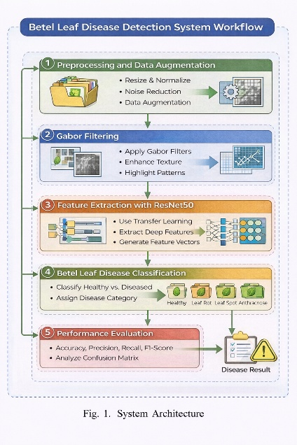
Fig 1: System Architecture
In this step, deep feature extraction and classification is then performed by using the convolutional neural network with the ResNet50 structure. It applies transfer learning at the time of network weight initiation and weights of the network have already been trained and is used in acquiring discriminative features using the available information. These features that are extracted are applied to classify the leaves as healthy or into separate diseases. Lastly, the system architecture will entail an evaluation component whose scope will be to determine the extent to which the proposed system is dependable in reference to typical performance indicators. This framework will provide proper diagnosis of illnesses.

C. Flow Chart
Fig 2 indicates the structure of proposed system in general. The workflow begins with collection of a betel leaf images dataset of a number of online data sources. These images are comprised of healthy and disease infected leaves. The collection of data serves as the input of the first part of the system.
The input images are pre-processed in the following step to make them uniform and diverse which is conducive to the deep learning model. Preprocessing is done so as to have fixed image resolution such as resizing, normalization and noise removal. The reason behind this is to ensure that all pictures are fed as input into CNN model in good standard condition.
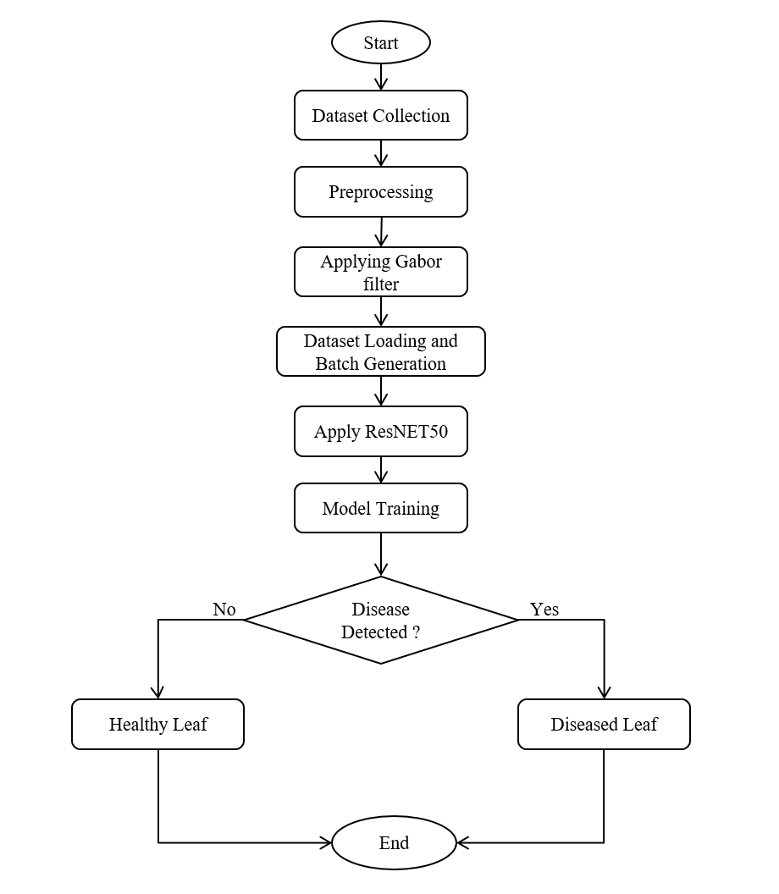
Fig 2: Flow Chart
The input images are pre-processed in the following step to make them uniform and diverse which is conducive to the deep learning model. Preprocessing is done so as to have fixed image resolution such as resizing, normalization and noise removal. The reason behind this is to ensure that all pictures are fed as input into CNN model in good standard condition.

Mathematical Equations
Gabor filtering is used to increase the texture data of disease relating on the leaf surface. Each grayscale images are tested again with some Gabor kernels of different orientation to identify directional texture (spots, rots, surface irregularities). Gabor filter 2-dim is mathematically equivalent to:
$G\left(x,y\right)=\exp\left(-\frac{x^{'2}+gamma^{2}y^{'2}}{2sigma^{2}}\right)\cos\left(\frac{2pi}{lambda}x^{'}+ psi\right)$ (1)

$x^{'}=\operatorname{xcos}{θ}+\operatorname{ysin}{θ}$ (2)
$y^{'}=-\operatorname{xsin}{θ}+\operatorname{ycos}{θ}$ (3)
Where λ is wavelength, θ is the orientation of filter, σ is the Gaussian envelope, γ is the ratio of the spatial aspects, and ψ is the phase offset. The RGB image is combined with the result of two filters at various angles and normalised down and subsequently added to the original image in order to preserve the colour information. During training, the ResNet50 model was trained on the Adam optimizer, batch size of 32 and 25 epochs.
The model was trained using Python with the TensorFlow libraries. The dataset used in this consists of 2635 images such that each class has 537 images. To enable effective training and evaluation, dataset is divided into batches whereby 70 percent of the total dataset is used in training, 15 percent in validation and 15 percent in testing. In order to generalize more and reduce overfitting, data augmentation controls such as rotation, shifting, zooming, shearing, and horizontal flipping are applied only on training set.
The image batches of augmentation are subsequently transformed through the ResNet50 convolutional neural network to extract features and classify them. ResNet50 is a 50-layer residual network, which is aimed at overcoming the vanishing gradient problem by using residual learning. Residual mapping can be defined as:
$y=F(x)+x$ (4)
and x is the input to the residual block and F(x) is the residual learned. This architecture allows effective learning of not just high-level features such as disease patterns, but also low-level features such as edges and textures. Transfer learning can also be used to achieve faster convergence and higher performance with smaller volumes of training data to begin with pre-trained weights.
Once the model has been trained, it passes to the stage of detecting the disease. In the trained model, an input image is used to identify a healthy or diseased leaf. The system further classifies the leaf under the right disease category in case a disease is detected. In case a disease is not observed, the leaf is said to be healthy. The workflow is then completed, and the stage of disease identification is completed.

D. Algorithm
- Dataset collection and assigning into different classes.
- Applying Gabor filter on the dataset images.
- Split dataset into Train, Validation, Test.
- For each image in Train perform augmentation.
- Load ResNet50 model.
- Now train the model for selected number of epochs.
- Evaluate model on Test dataset.
- Check the performance metrics.
- RESULT ANALYSIS
An ablation experiment was conducted, where the ResNets50 model has been trained with the Gabor filter and without it. This showed that the suggested method of Gabor-enhancing led to a higher classification accuracy in comparison with the baseline ResNet50 model. This observation proves that the use of texture-enhancing achieves an enhancement in the ability of the model to capture disease-relevant features evinced in betel leaf images.
This Table 2 showed how the model has worked out in the classification of the different betel leaf conditions by applying the metrics of accuracy, precision, recall, and F1-score. The model has the top scores of the Anthracnose and Bacterial Leaf types, and each of the metrics is 99%. The accuracy in the Healthy Leaf class is unusually high and equals 99%. The Leaf Rot also shows a great performance as all of the metrics are close to 99% therefore, validating the ability of the model to distinguish between the occurrence of leaf rot with almost zero error rates. In the case of Leaf Spot, the accuracy is maintained at a high rate of 98%. This diminished precision indicates that there are a limited number of cases that will be have different classes of diseases the model is also able to detect Leaf Spot reliably.
Table 2: Performance Metrics
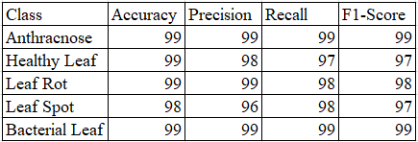
$\text{Accuracy}=\frac{TP+TN}{TP+TN+FP+FN}$ (5)
$\text{Precision}=\frac{TP}{TP+FP}$ (6)
$\text{Recall}=\frac{TP}{TP+FN}$ (7)

$\text{F1-score}=2×\frac{\text{Precision}×\text{Recall}}{\text{Precision}+\text{Recall}}$ (8)

Confusion Matrix
Fig. 3 showed the normalized confusion matrix of the proposed system. The predicted accuracy of the model is measured by the matrix which compares the true class labels and the predicted labels. Both diagonal and off-diagonal cells represent the misclassifications and correct classifications respectively.
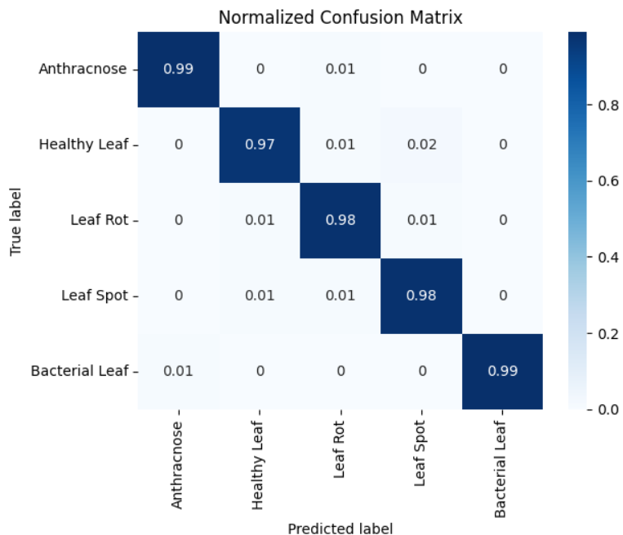
Fig 3: Confusion Matrix
In general, most of the predictions cluster around the main diagonal in the confusion matrix, which highlights the fact that the combination of a Gabor filter front-end and a ResNet50 provides an effective and efficient system in terms of separating healthy and diseased leaves of the betel.
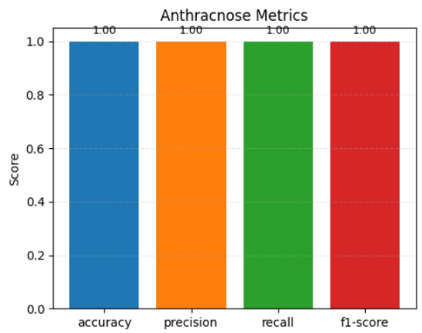
Fig 4: Performance metrics of Anthracnose leaf
The Fig. 4 shows the graphical representation of the performance metrics of the Anthracnose leaf.
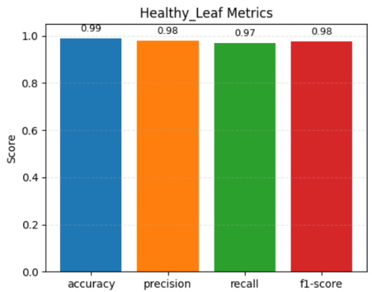
Fig 5: Performance metrics of Healthy leaf
The Fig 5 illustrates the graphical representation of the performance measures on the Healthy leaf class.
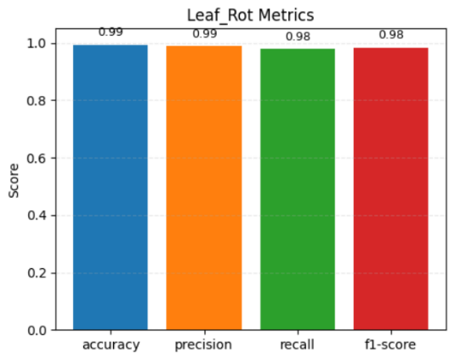
Fig 6: Performance metrics of Leaf Rot leaf
The Fig 6 shows the performance values of Leaf Rot class.
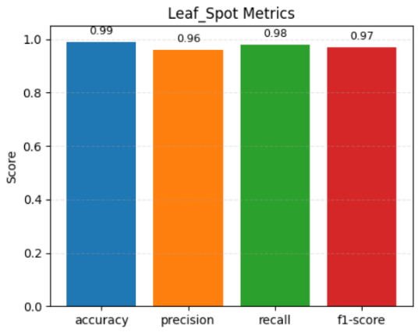
Fig 7: Performance metrics of Leaf Spot leaf
The Fig 7 shows the performance of the Leaf Spot class.
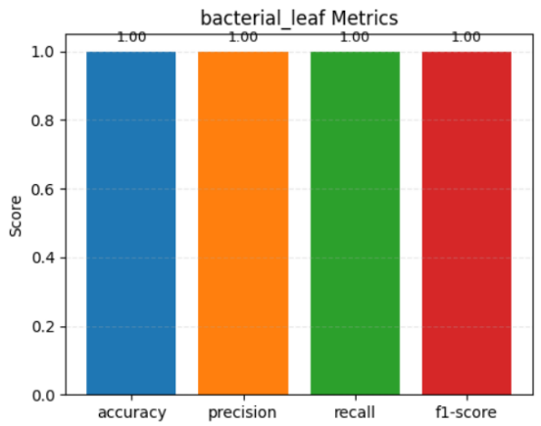
Fig 8: Performance metrics of Bacterial leaf
In Figure 8, the performance measures of the Bacterial leaf class.
- DISCUSSION
The theoretical framework proposed can increase the number of features detected and the number of types of diseases detected. The nature of the previous studies where VGG16 was used with PCA was generally limited to three types of diseases, and less accurate. In comparison, the present approach differentiates five classes of diseases, hence making it easier to identify a pathological disease in a more detailed and specific way.
A combination of Gabor filtering and the ResNet50 architecture enabled the model to combine high-level disease-related data. Gabor filters enhance fine texture patterns and edge changes that are part of disease manifestation whereas deep residual network retrieves higher-level semantic features of the processed images. This aspect of synergistic feature-learning approach significantly reduces the rate of misclassification between the classes of the disease. Therefore, the suggested solution will be more applicable to real-world situations of agriculture where timely and reliable disease diagnosis takes priority.
- CONCLUSION
This paper outlines an effective procedure of detecting diseases in betel leaves by using the texture enhancement and deep-learning algorithms. Gabor filters were additionally used to highlight disease texture patterns meanwhile a ResNet-50 convolutional neural network was being used to perform multi-class classification. The proposed model showed high accuracy in all types of the diseases, thus justifying the effectiveness of the model to correctly differentiate between health and disease leaf. Compared with previous methods, the offered system increased the range of distinguishable disease types and simultaneously minimized the misclassification rates. Generally, the framework provides an efficient solution to early disease detection hence enhancing better crop management and increased productivity in the culture of betel leaves.
- FUTURE WORK
Future developments of the suggested framework can enable greater classification of the betel leaf disease with classification categories addressing incident leaf conditions. Thus, the application of the given circumstances and related classification types as the foundation of the artificial intelligence model allows prescribing, treating and preventing the instances of the conditions noticed by farmers based on the experience gained via the artificial intelligence model. By training and testing the model on a greater number of larger and more diverse datasets that have been collected covering a range of different growing conditions, it will become possible to enable that model to acquire greater generalizability and resilience when applied to practice in the realm of agriculture. With the combination of field sensors with mobile applications that can capture images, real-time, and the identification or detection of diseases in the field using the image capturing mobile devices, this could be possible.
REFERENCES

- R. H. Hridoy, M. T. Habib, I. Mahmud, A. Haque, and M. A. Al Mamun, “A comprehensive image dataset for accurate diagnosis of betel leaf diseases using artificial intelligence in plant pathology,” Data in Brief, vol. 60, 2025, doi: 10.1016/j.dib.2025.111564.
- A. S. Devi and S. A. Albert Antony Raj, “Optimized betel leaf disease detection using improved CNN model for precision agriculture,” Journal of Electrical Systems, vol. 20, no. 10s, 2024.
- F. David and M. A. Mukunthan, “Betel leaf diseases classification using machine learning algorithm: A feasible approach,” Journal of Advanced Research in Applied Sciences and Engineering Technology, vol. 40, no. 1, 2024, doi: 10.37934/araset.40.1.7486.
- I. Kumar and R. Verma, “Betel plant leaf age and disease detection using K-means clustering,” International Journal of Innovative Research in Science, Engineering and Technology, vol. 9, no. 5, 2020.
- G. Rajkumar, T. Gayathri Devi, S. Karthikeyan, and A. Srinivasan, “Enhancing betel vine leaf disease diagnosis through machine learning techniques,” Scope Journal, vol. 13, no. 2, 2023.
- A. Banerjee and R. Ghosh, “Fungal diseases of betel vine (Piper betle L.) in India and their management: An overview,” Journal of Mycopathological Research, vol. 62, no. 1, 2024, doi: 10.57023/JMycR.62.1.2024.021.
- S. Mishra, R. Kumar, and P. Singh, “Deep learning-based plant leaf disease detection using transfer learning techniques,” Computers and Electronics in Agriculture,vol.205,2023,doi:10.1016/j.compag.2023.107600.
- H. Chen, Y. Zhang, and L. Wang, “Attention-based convolutional neural networks for plant disease recognition in smart agriculture,” IEEE Access, vol. 11,pp.75214–75226,2023,doi:10.1109/ACCESS.2023.3284567.
- R.-U. Khan et al., “Betel leaf disease recognition using machine learning and convolutional neural networks,” Lecture Notes in Networks and Systems, Springer, 2024.
- R. Singh, K. Patel, and M. Sharma, “Automated plant disease classification using hybrid CNN–Transformer model,” Expert Systems with Applications, vol. 228, 2023, doi: 10.1016/j.eswa.2023.120335.
- S. Ahmed, M. B. Hasan, T. Ahmed, M. R. K. Sony, and M. H. Kabir, “Less is more: Lighter and faster deep neural architecture for tomato leaf disease classification,” IEEE Access, vol. 10, pp. 68868–68884, 2022.
- M. A. Rahman, T. Hasan, and M. S. Islam, “Plant leaf disease detection using lightweight deep learning architecture for mobile applications,” Computers and Electronics in Agriculture, vol. 210, 2024, doi: 10.1016/j.compag.2024.108123.
- P. R. Nair, S. K. Menon, and V. Babu, “Transfer learning-based plant disease recognition using EfficientNet models,” Artificial Intelligence in Agriculture, vol. 10, 2024, pp. 35–46, doi: 10.1016/j.aiia.2024.02.005.
- P. Kaur, S. Harnal, R. Tiwari, S. Upadhyay, S. Bhatia, A. Mashat, and A. M. Alabdali, “Recognition of leaf disease using hybrid convolutional neural network by applying feature reduction,” Sensors, vol. 22, no. 2, p. 575, 2022.
- J. Liu, Q. Li, and X. Zhao, “Vision transformer-based plant leaf disease detection in precision agriculture,” Biosystems Engineering, vol. 238, 2024, doi: 10.1016/j.biosystemseng.2024.01.012.
- R. Kumar, A. Chug, A. P. Singh, and D. Singh, “A systematic analysis of machine learning and deep learning-based approaches for plant leaf disease classification: A review,” Journal of Sensors, 2022.
- K. S. Reddy, P. Kumar, and D. Rao, “Real-time plant disease identification using deep learning and IoT-enabled smart farming,” Sensors, vol. 24, no. 3, 2024, p. 1056, doi: 10.3390/s24031056.
- L. Torres, M. Garcia, and E. Fernandez, “Explainable AI for plant disease diagnosis using deep convolutional neural networks,” Computers in Biology and Medicine, vol. 170, 2025, doi: 10.1016/j.compbiomed.2024.108020.
- A. S. Zamani et al., “Performance of machine learning and image processing in plant leaf disease detection,” Journal of Food Quality, 2022.
- R. Kumar, A. Chug, A. P. Singh, and D. Singh, “A systematic analysis of machine learning and deep learning-based approaches for plant leaf disease classification: A review,” Journal of Sensors, 2022.

